Build Document for OS-Vent Ventilator Pneumatic Assembly without Exhalation Valve
V 1.0; March 29, 2020
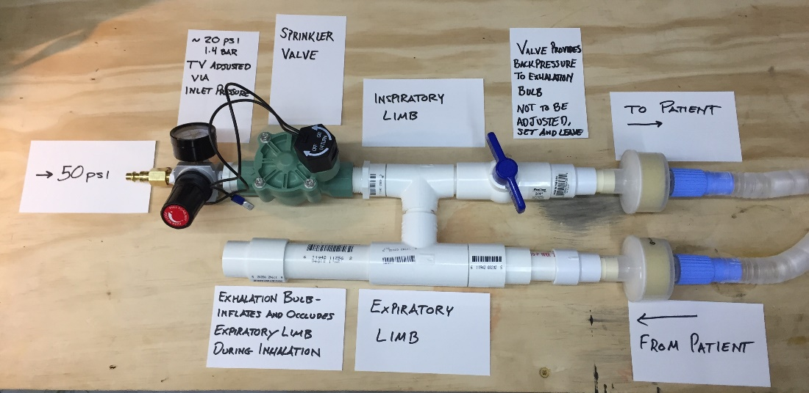
Figure 1. Ventilator Assembly - Pneumatics

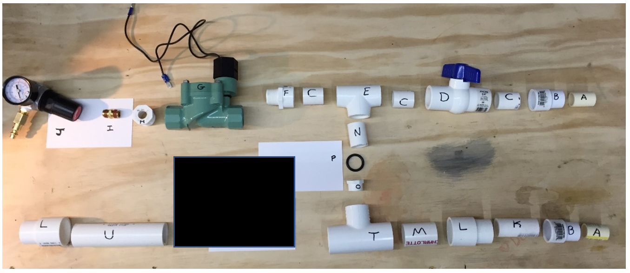
Figure 2. Ventilator Assembly – Pneumatics - Exploded View – Exhalation valve blacked out until safety and endurance testing is completed

